**INTRODUCTION**

* 1. **Overview**

**\* This global air transportation network data set is a comprehensive collection of information an airports, airlines and their routes. It contains information such as names, cities, countries, codes (IATA and ICAO ) longitudes, latitudes and altitudes of airports across the world with detailed time zone and daylight saving time data. Additionally, this includes information about airlines including their IDs, name aliases, IATA and ICAO codes, callsigns country of origin and active/inactive status.**

* 1. **purpose**

**\* Air transport is one of the fastest modes of public transport which connects international boundaries. Air transport allow people from different countries to cross international boundaries and travel other countries for personal, business, medical, and tourism purposes.**

**2.1EMPATHYMAP** 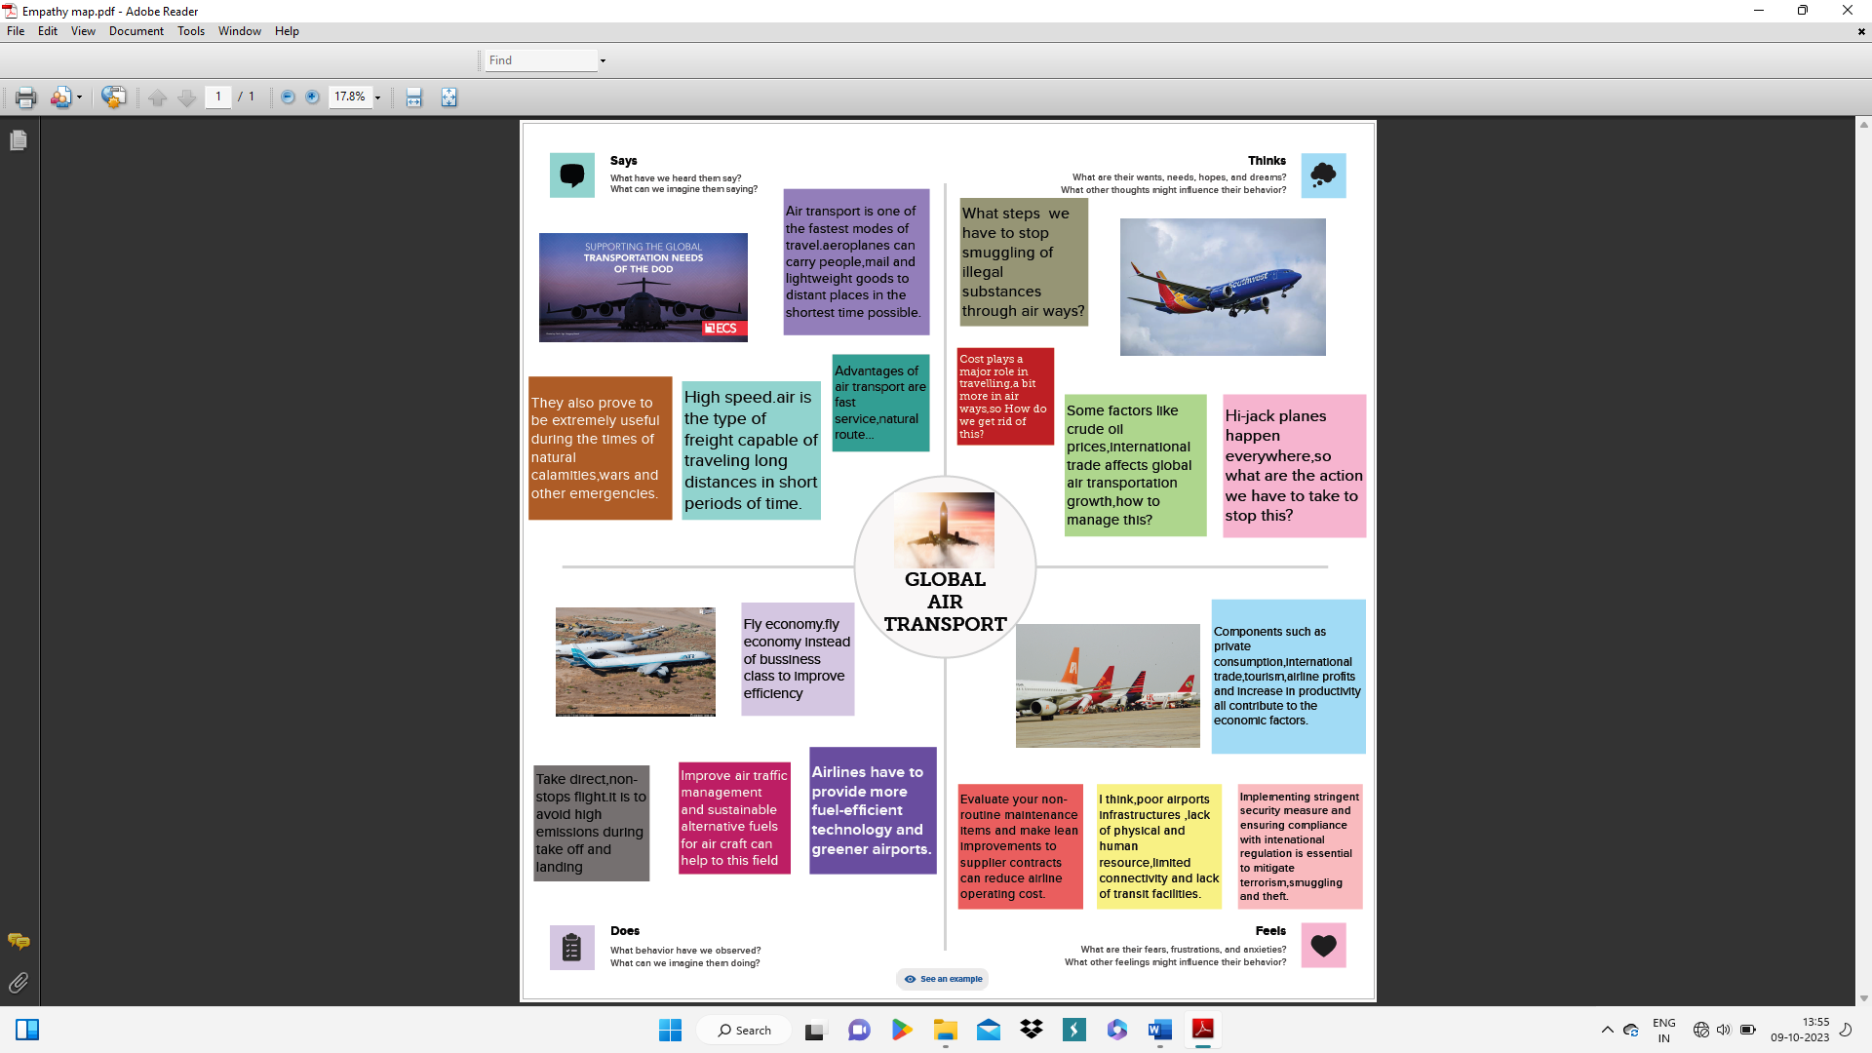

2.2 BRAINSTROMING MAP

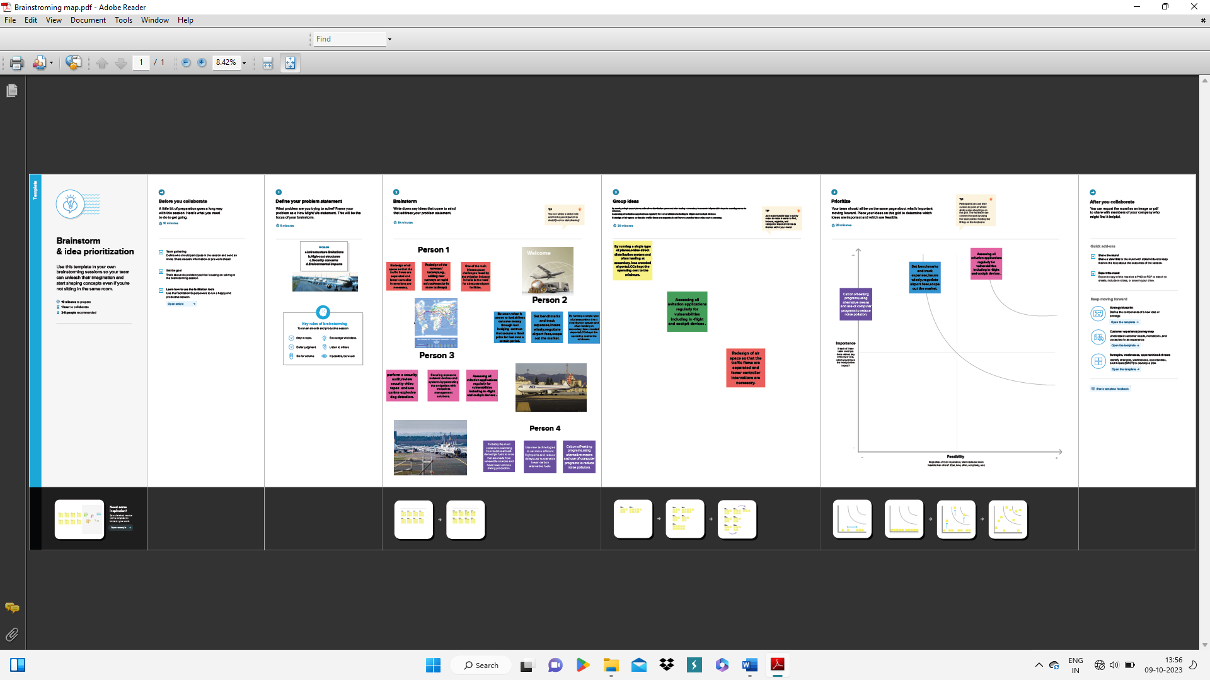

RESULT

This global air transportation network dataset is a comprehensive collection of information on airports, airlines and their routes. It contains information such as names, cities, countries, codes (IATA and ICAO) longitudes, latitudes and altitudes of airports across the world with detailed time zone and daylight-saving time data.

DASHBOARDS 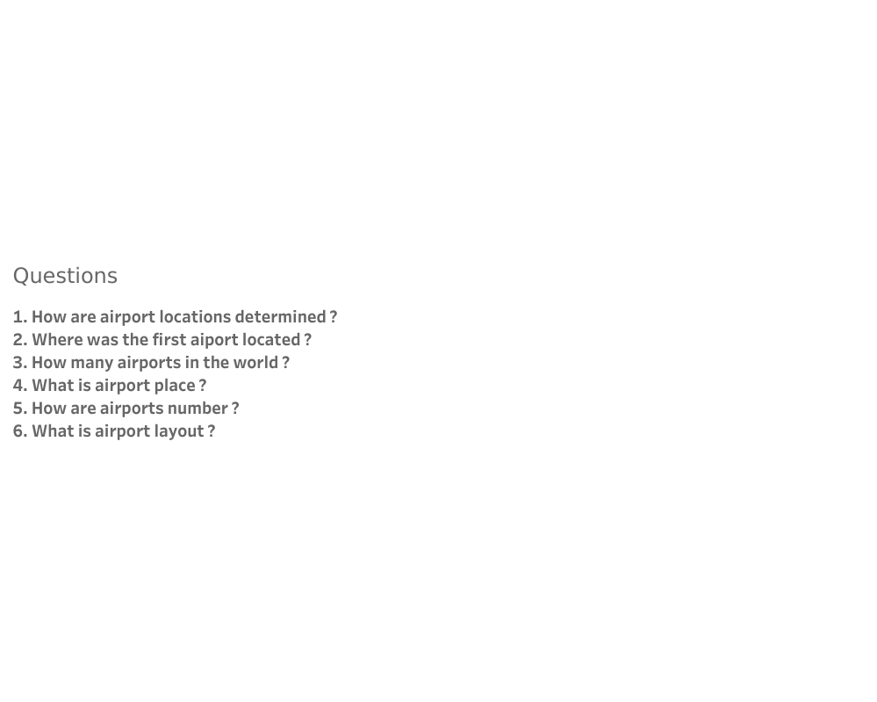

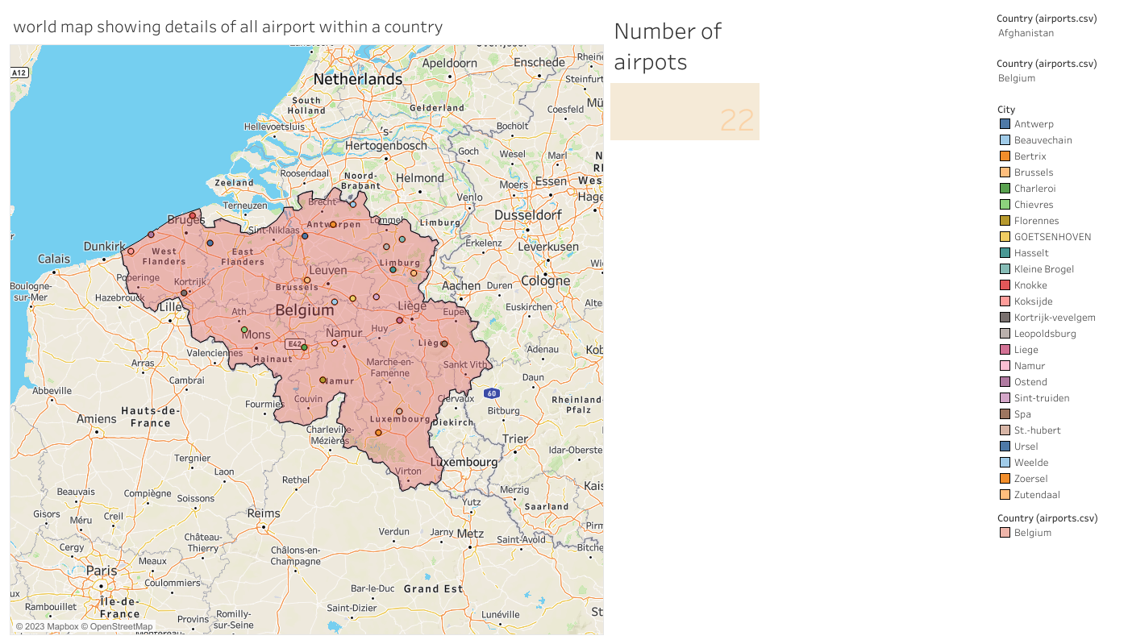

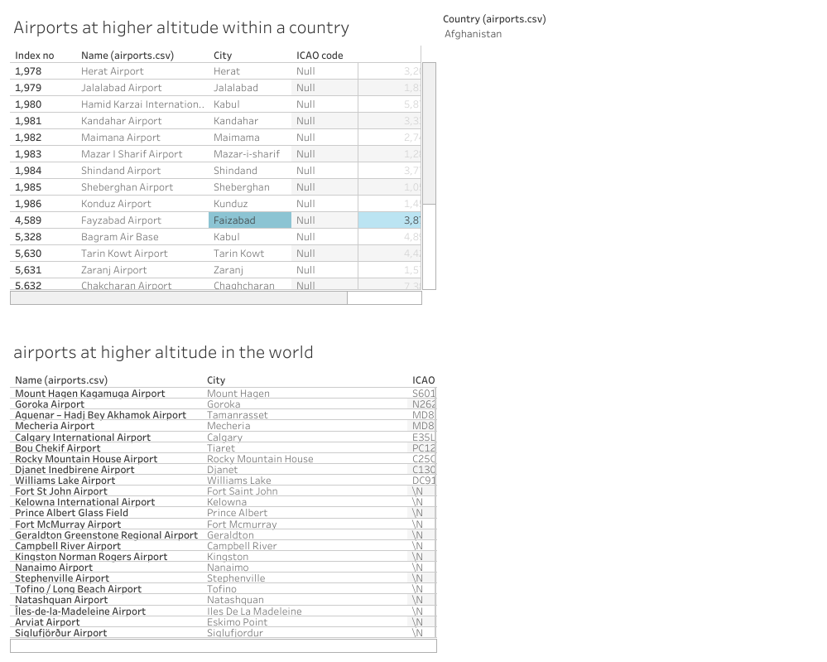

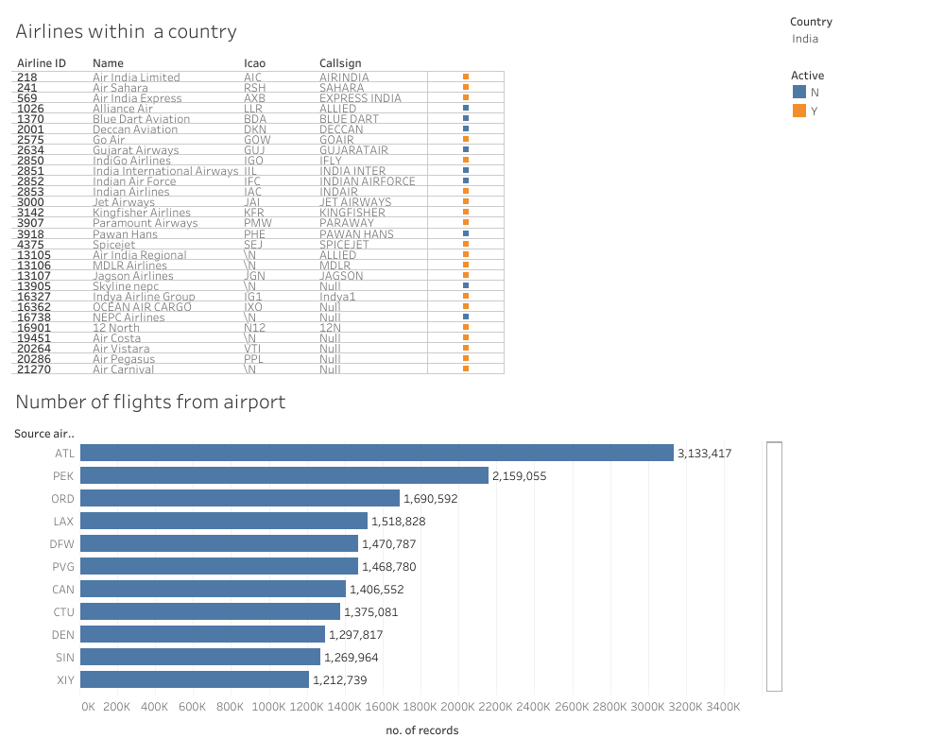

ADVANTAGES

High speed air is the type of freight capable of travelling long distances in short periods of time

Fast services , send almost everywhere your freight, high standard of security, natural route and there is less need for heavy packaging

DISADVANTAGES

Air transport can involved higher costs than other options, and is not suitable for all goods.

Flights are subject to delay or cancellation.

You will need to pay taxes at each airport you use.

APPLICATIONS

IATA aims to be the force for value creation and innovation driving a safe, secure and profitable air transport industry that sustainable connects and enriches the world. IATA’s mission is to represent, lead, and so the airline industry. IATA was founded in Havana, cuba, in April 1945.

CONCLUSION

The Indian aviation industry has undergone significant developments and growth in recent years.

FUTURE SCOPE

Emerging technologies are reshaping with robotics, artificial intelligence, the internet of things, unmanned aircrafts systems and the push for hybrid and electric air planes.